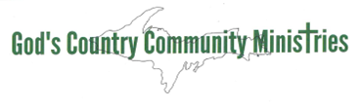
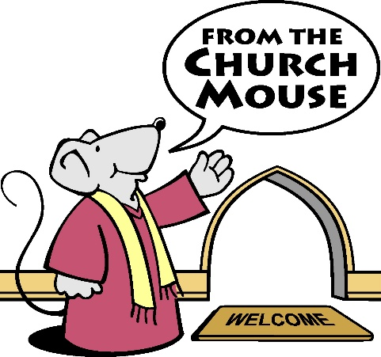
GCCM NEEDS LIST – Church Mouse Program
-You heard the call for help and answered it magnificently –

Last updated 8/4/2026

Personal Hygiene Items
Men’s Items – 50 each | Women’s Items – 50 each | Baby Items
Razors | Razors | Diapers, Boys – NB thru XL
Shaving Cream | Shampoo | Diapers, Girls – NB thru XL
Shampoo | Conditioner | Baby Shampoo
Conditioner | Deodorant | Baby Body Wash
Deodorant | Hair Brushes | Baby Lotion
Hair Brushes | Combs
Combs | Toothpaste
Toothpaste | Toothbrushes
Toothbrushes | Feminine Pads | Children
Liquid Soap | Tampons | Shampoo
Lotion | Liquid Soap | Body Wash
Loofahs/Net Wash Sponges | Lotion | Toothpaste
 | Loofahs/Net Wash Sponges | Toothbrushes
Household Items
Toilet Paper Dish Soap
Containers of Laundry Soap Containers of Stain Remover
Spray & Wash Oxi Clean
Blankets Bed Sheets – all sizes
New Pillows (we are not allowed to give used pillows away)

Clothing for Infants, Children and Adults
Rain Boots for Children 2 thru 10 years old
Snow Boots for Children 2 thru 16 years old
NEW Tennis Shoes for Children 2 thru 16 years old
Children’s Flip Flops & Crocs
Snow Pants (black goes with anything) sizes 2T thru 16
Snowsuits for 12 & 18 month olds
Winter Coats for Men M, L, XL, XXL, XXXL
Waterproof Mittens for Children – sizes NB thru 16
Jackets for Teens (Men’s M, L & Women’s S, M, L)
Jackets for Children 2T – Size 12
Infant Sleepwear – one piece/warm (NB thru 6X)
Children’s Flannel pajamas – girls and boys 6X thru 16
Pajama Pants – Adult S, M, L, XL, XXL
Pajamas – girls and boys 6X thru 16
Night Gowns – girls 2T thru 6T
Sweatshirts – girls and boys 2T thru 16
Sweatshirts – Adult XS thru XXXL unisex
Adult Sweatpants/Jogging pants – S thru XXXL
Jeans – Boys size 3 thru 16
Jeans – Men’s HIGH NEED for these
No Need of Women’s sizes Large, XL or XXL clothing – Thank you
Shorts – All sizes Men, Women and Children
Long Sleeve Shirts – Girls and Boys sizes 3 thru 16
Short Sleeve T-Shirts – Girls and Boys sizes 3 thru 16
Tank Tops – Girls and Boys sizes 3 thru 16
Adult Men’s T-Shirts – sizes Small thru XXL
Women’s Cotton Underwear (Bikini or Thigh High) – XS, S, and M only
Young Ladies and Women’s Cotton Cami bras – XS, S, and M only
Men’s and Boy’s Boxers and Boxer Briefs – all sizes (HIGH NEED for XXL and XXXL)
Socks – all sizes, men, women and children. Footie socks are appreciated.

Baby Clothes – Anything Cute, especially 1 piece pajamas (onesies) premie thru size 3

We are so grateful for new or slightly used items and appreciate you laundering the clothing before donating. To avoid damage, please do not ship clothing in hangers. No polyester please.

